Name: _________________________Date: _____________
Math Homework #18
Please use these math related questions to support your child at home with first grade math concepts being addressed. If they complete and return their homework on Fridays, they will receive 2 Wizard Wows. This is NOT a graded assignment.
Review  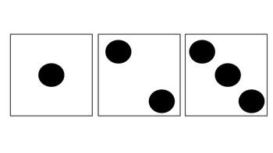  How many dots do you see in all? ______  What addition strategy could you use to help you?  _______________________________ | Current  Bridging to Ten  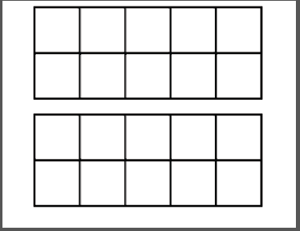  ______ + ______ = ______  OR  ______ + ______ = ______
Fluency Practice: Make a Ten Addition  - 8 + 2 = ___  - 4 + 6 = ___  - 3 + 7 = ___  - 7 + 3 = ___  - 5 + 5 = ___  - 1 + 9 = ___  - 0 + 10 = ___ | Fluency Practice: Make a Ten Subtraction  - 10 - 2 = ___  - 10 - 4 = ___  - 10 – 3 = ___  - 10– 5 = ___  - 10 - 7 = ___  - 10 - 1 = ___  - 10 - 6 = ___

