Name: _________________________Date: _____________
Math Homework #6
Please use these math related questions to support your child at home with first grade math concepts being addressed. If they complete and return their homework on Fridays, they will receive 2 Wizard Wows. This is NOT a graded assignment.
Review  You have been given the two parts. Can you determine the whole? Write an addition equation to match.  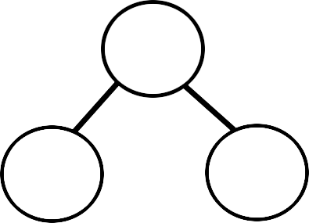  ______ + ______ = ______  Part + Part = Whole | Current  Circle 4 hexagons. How many more do you need to make a group of 6?  4 + ___ = 6  Part + Part = Whole
Fluency Practice  - 3 + 4= _______  - 4 + 3= _______  - 2 + 5= _______  - 5 + 2 = _______  - 8 + 1= _______  - 1 + 8= _______  - 2 + 6= _______  - 6 + 2 = _______ | Real Life Connections  Complete the Fact Family House using the following numbers:  3, 7, 10  