Name: _________________________Date: _____________
Math Homework #20
Please use these math related questions to support your child at home with first grade math concepts being addressed. If they complete and return their homework on Fridays, they will receive 2 Wizard Wows. This is NOT a graded assignment.
Review  Fill in the missing numbers  - ____, 25, 26, 27, ____  - 67, ____, 69, 70, ____  - 46, ____, 48, 49, ____ | Current  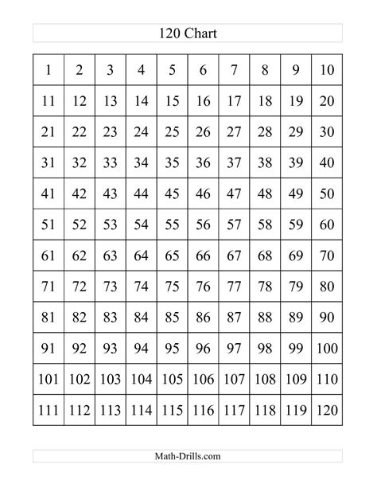  - Start with number 23 and count on to 120.  - Start with number 65 and count on to 120.  - Start with number 100 and count on to 120.
Real Life Connection:  I have one dime and 7 pennies.  What is my total amount?  _____ _____  Ten Ones | Fluency Practice: Mixed Review Addition  - 5 + 2 = ___  - 3 + 1 = ___  - 4 + 4 = ___  - 6 + 0 = ___  - 8 + 2 = ___  - 1 + 1 = ___  - 9 + 0 = ___  - 7 + 2 = ___

